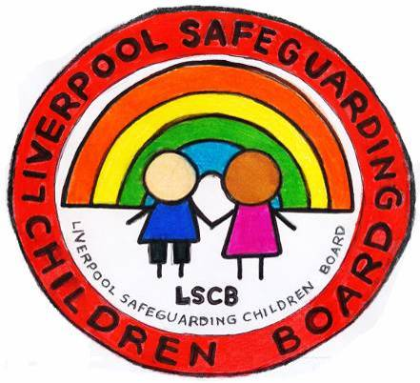
Helpful links for Young People
CEOP Online Resources for Young People
http://www.thinkuknow.co.uk/

A website designed by young people for use by young people on staying safe
http://www.ayph-behealthy.org.uk/

A leaflet from Barnardos - Be aware, stay alert, keep safe!
http://www.barnardos.org.uk/spot_the_signs_cyp.pdf

A mini booklet about Child Sexual Exploitation
http://safeguardingni.org/sites/default/files/sites/default/files/imce/CSE%20Kids%20Leaflet.pdf

Healthy Relationship Checklist
http://thisisabuse.direct.gov.uk/worried-about-abuse#relationship-checklist
A booklet of creative writing by young people who are at risk of, or who have experience of, sexual exploitation
https://www.safeguardingsheffieldchildren.org.uk/welcome/sheffield-safeguarding-children-board/sexual-exploitation.html?showdetails=Show&uuid=67673984-2eb9-4ec8-b56c-caccb8838eda

Your Guide. Sex, Secrets and Lies.
http://www.barnardos.org.uk/_sex__secrets_and_lies__brochure_-_english_version.pdf

