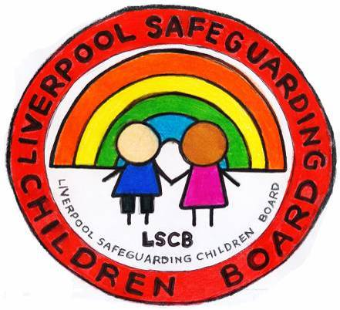
Helpful websites for Parents and Carers

Advice for parents about talking to your child about creating, sending or receiving explicit images:
http://www.nspcc.org.uk/help-and-advice/for-parents/talking-about-sex/sexting/sexting_wda96795.html
An e-learning tool for parents and carers:
https://keepthemsafe.safeguardingchildrenea.co.uk/
Support for parents and carers
http://www.paceuk.info/
This pack offers guidance on how to approach discussions with children about commercial content online:
http://www.mediasmart.org.uk/parents/digital_pack
Back to school basics for digital families:
http://www.slideshare.net/uKnowKids/back-to-schoolbasicsfordigitalfamilies-slideshare
Facebook privacy settings:
http://internet-safety.yoursphere.com/2013/01/facebooks-new-privacy-settings/
Top tips for iPhone, Blackberry, Nintendo, Playstation, Xbox, iPad and iPod touch:
http://www.kidsmart.org.uk/parents/parental-controls.aspx

Child Exploitation Online Protection (CEOP) Centre website for parents and carers:
https://www.thinkuknow.co.uk/parents/

Information for keeping your child safe online:
http://www.childnet.com/parents-and-carers

